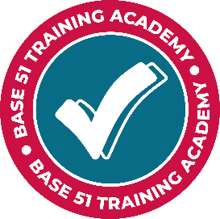
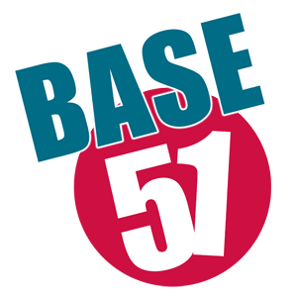

Qualified Sessional Youth Work Tutors
Hours: variable
Salary: £15.50 per hour (self-employed basis only)
Location: Nottingham city centre and online

Closing date for completed applications: ongoing

At Base 51 Training Academy we deliver accredited youth work training to people working with children and young people from across the Youth Work sector.
The training opportunities in Youth Work range from the Level 1 Certificate in Exploring Youth Work, through to accredited and JNC recognised Level 2 Certificate in Youth Work Practice and Level 3 Diploma in Youth Work Practice.
We have an exciting opportunity for trainers with the following essential criteria:
- JNC Professionally Qualified Youth Work practitioner who have undertaken a recognised professional qualification in youth work.
- Have a minimum of three years practical experience.
- Have a sound understanding of National Occupational Standards for Youth Work
- Have a sound understanding of the requirements for assessment within Ofqual
- Be able to evidence continued professional development within the last three years
- A flexible approach with the individual needs of learners needs’ as the priority
- An ability to work some evenings in accordance with learners’ needs
- An ability to work independently and manage the delivery of the scheme of work relevant to the course.
- Ability to set up as self-employed, and hold relevant insurances.

Using the indicative course content you will have the opportunity to provide your own teaching resources to teach groups of adult learners.

Base 51 have been delivering high quality youth work to young people for 30 years. We have a proven track record of improving the lives of the young people in and around Nottingham.

Based in the heart of the city centre, our facilities boast a gym, a dance studio and a recording studio. We can also provide food, showers and washing facilities for young people in need. We are passionate about offering young people a safe space where change can begin.

For more information or an informal discussion please call Nikki Hutt (Training Academy Coordinator ) on 0115 952 50 40.

For an application pack:
Download from www.base51.org/careers

Email info@base51.org.uk

Call 0115 952 50 40

Base 51 works with children and young people and applies safe working practice to all posts.

CV’s accepted, please forward with a covering letter to:
N.Hutt – n.hutt@base51.org.uk

